**Register Page**

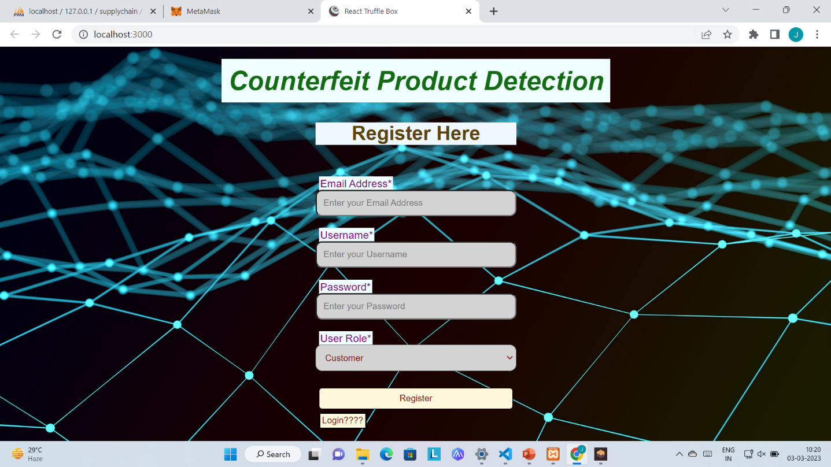

### Figure 6.2.1: Register Page

**Login Page**

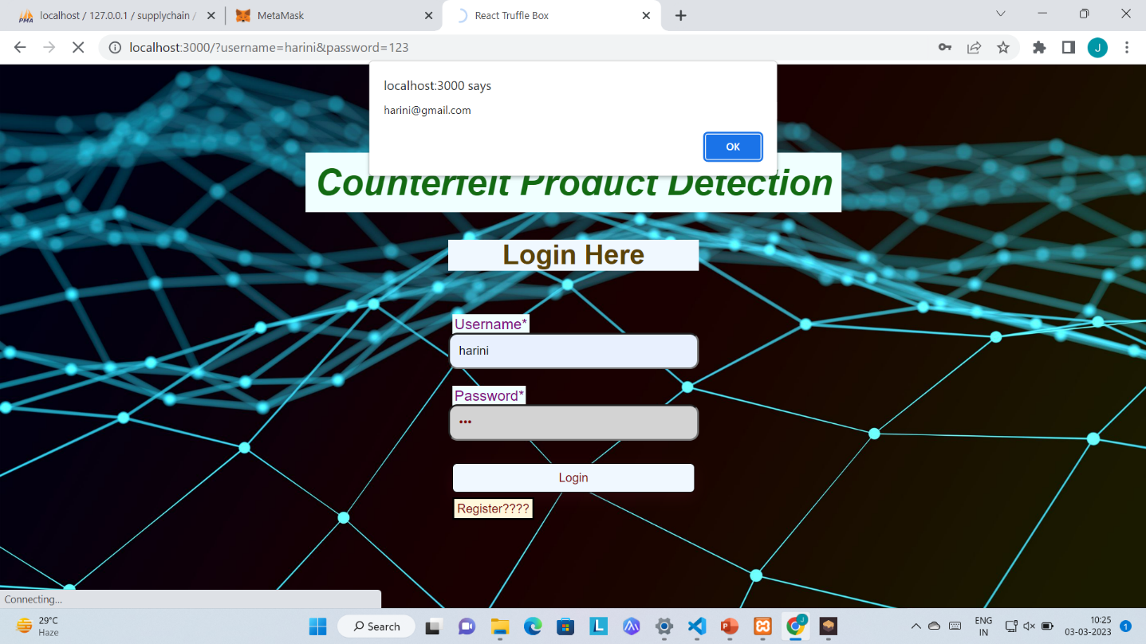

Figure 6.2.2: Login Page

**Home Page of Manufacturer**

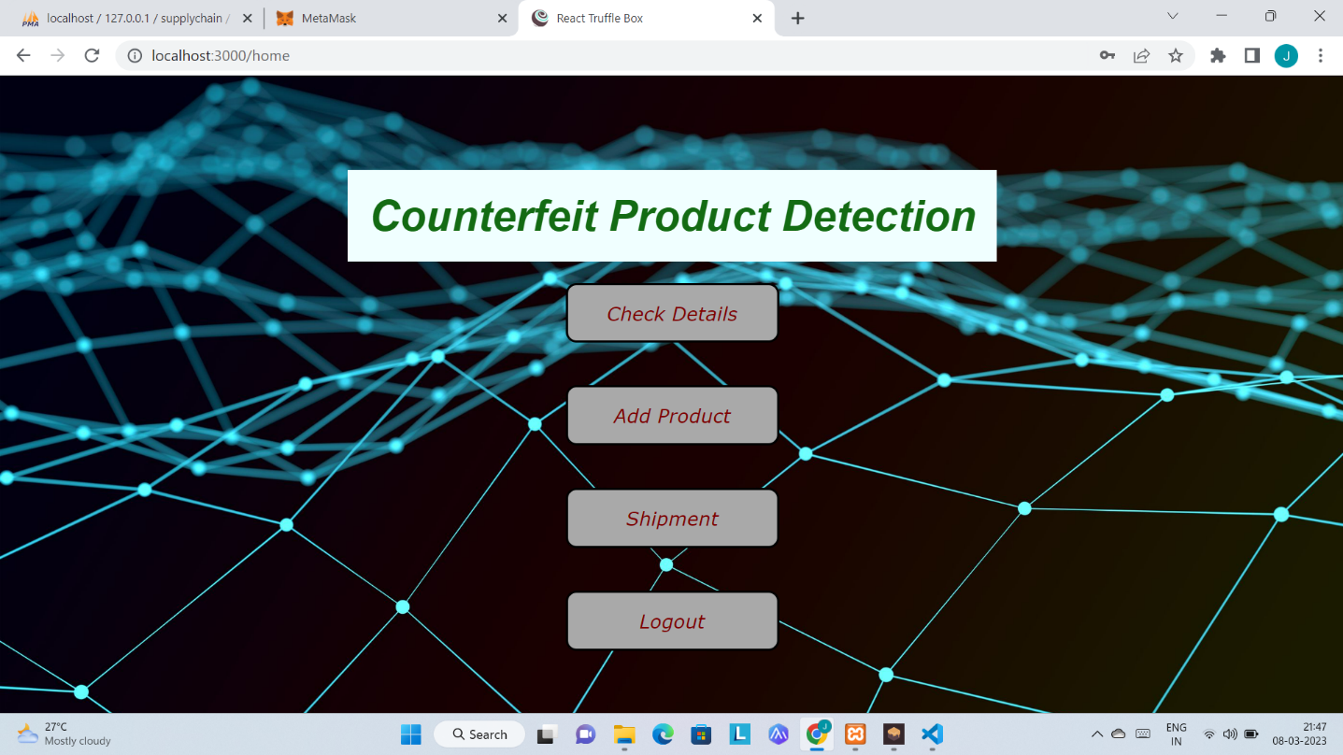

Figure 6.2.3: Home Page of Manufacturer

**Add a Product**

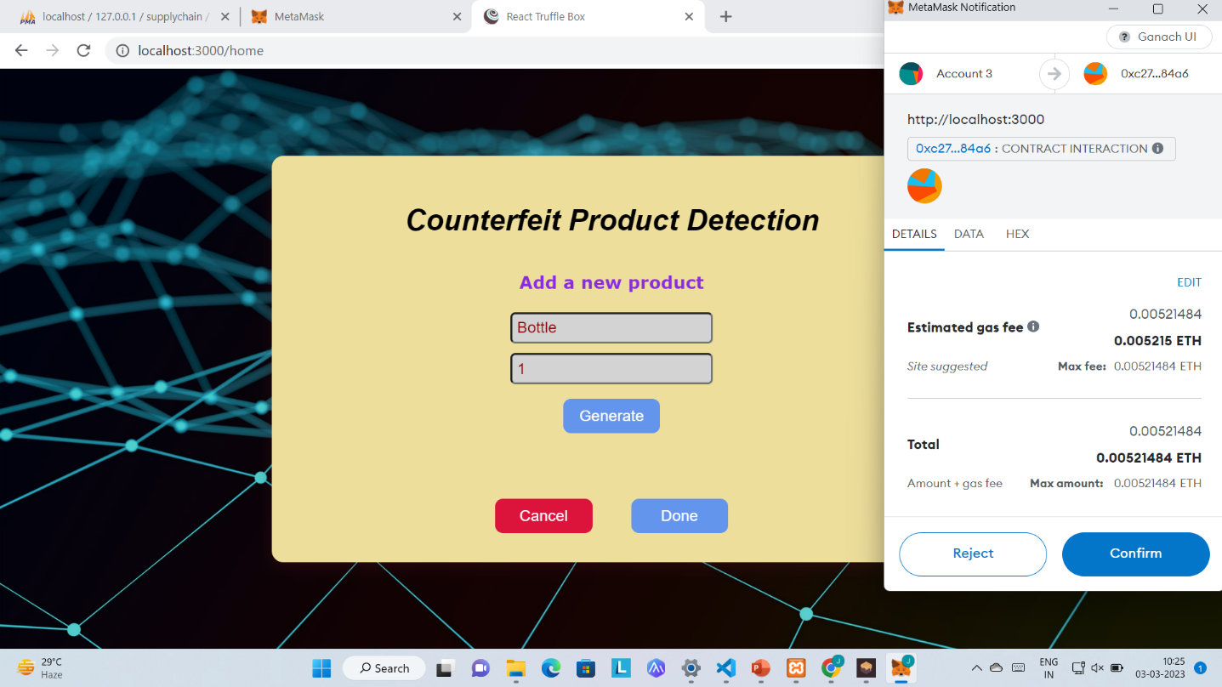

Figure 6.2.4: Page to add a product

**Successful adding a product**

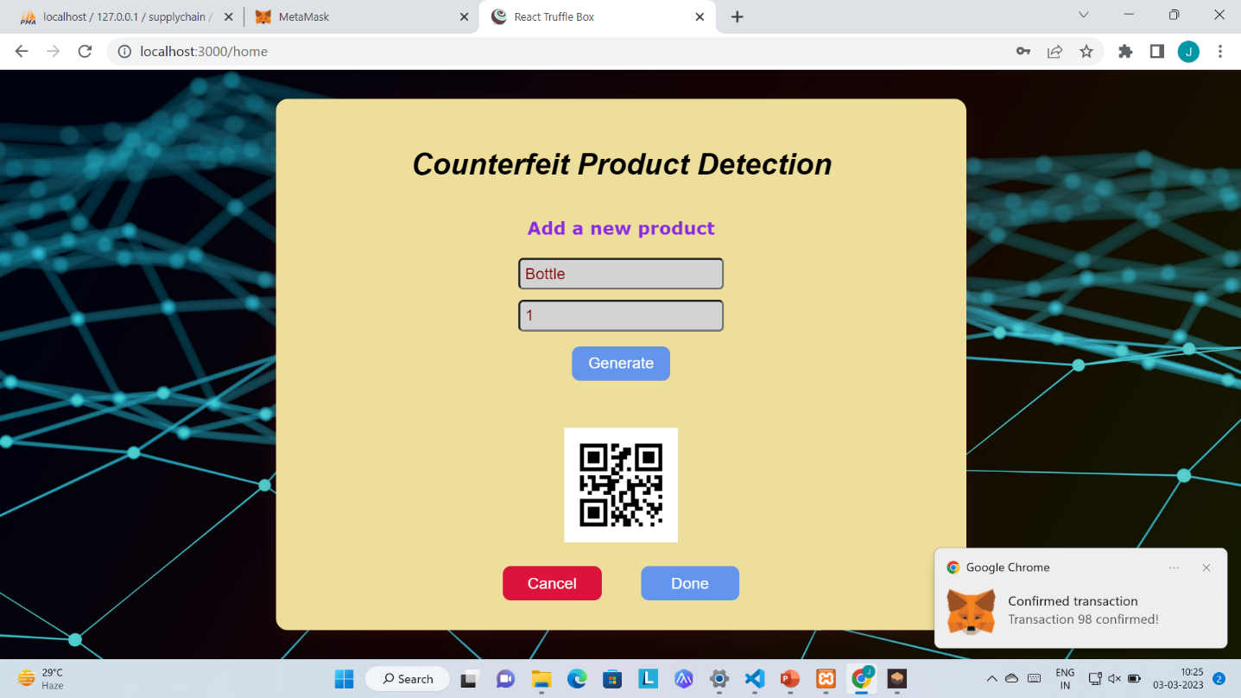

Figure 6.2.5: Successfully adding a product

**Ship a Product**

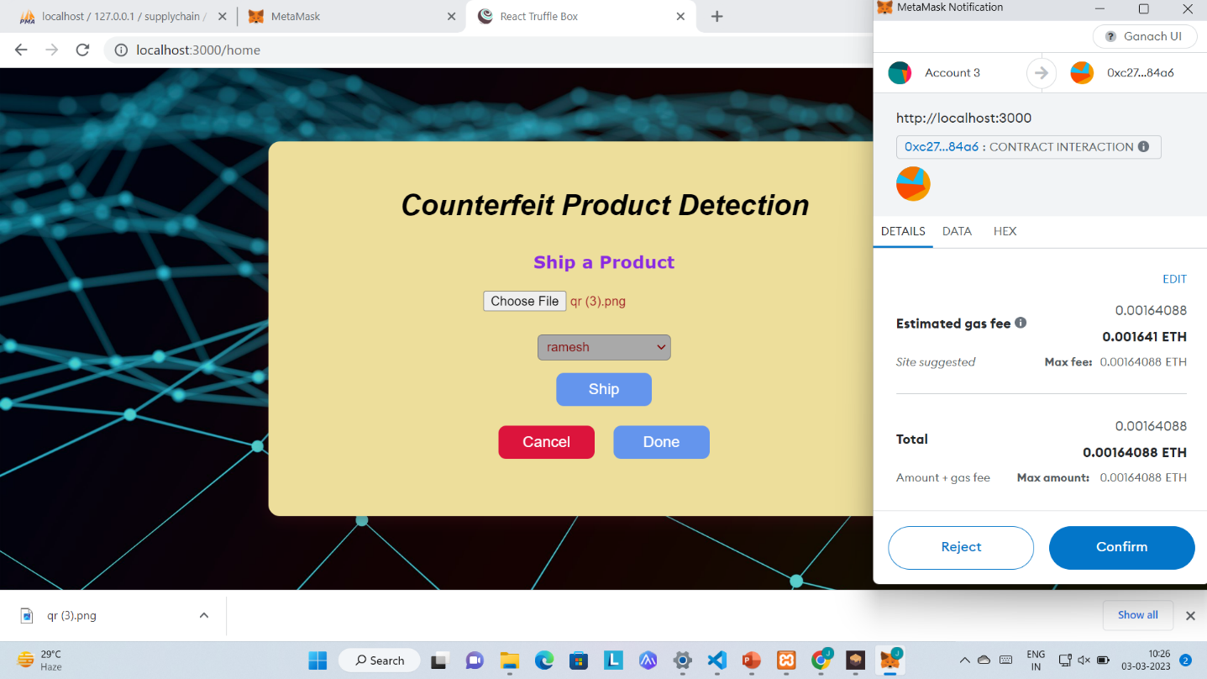

Figure 6.2.6: Page to Ship a product

**Shipping Successful**

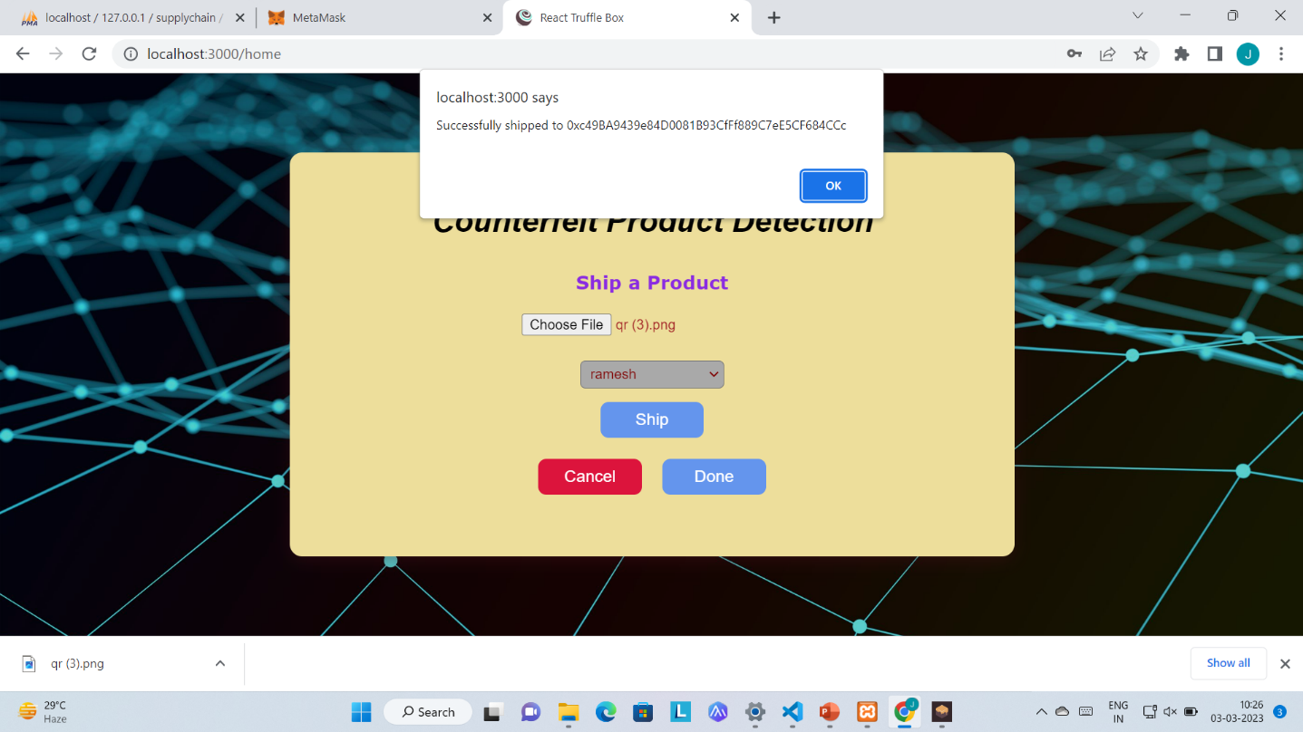

Figure 6.2.7: Shipment Successful Page

**Home Page of Distributor / Retailer**

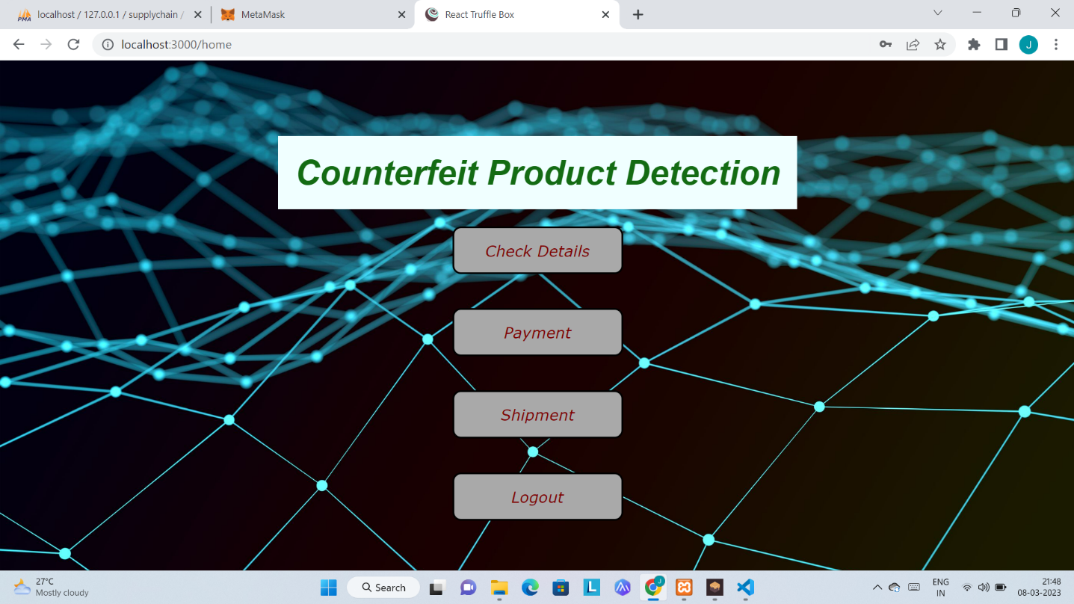

Figure 6.2.8: Home Page of Distributor/Retailer

**Check Product Details**

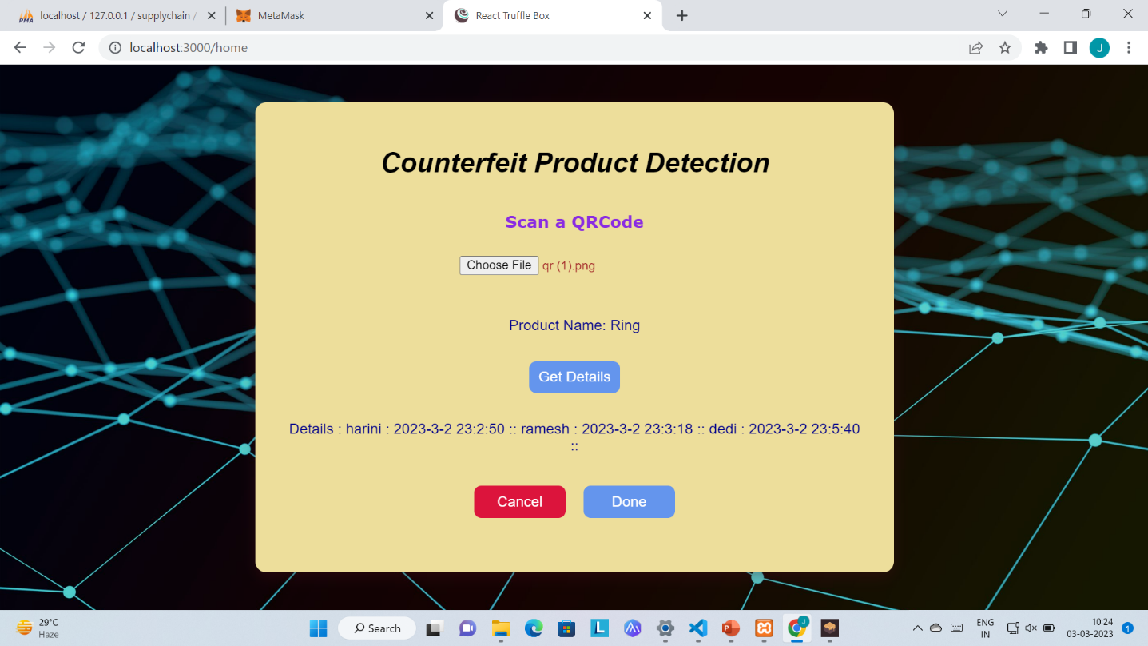

Figure 6.2.9: Check Product Details Page

**Check Fake Product Details**

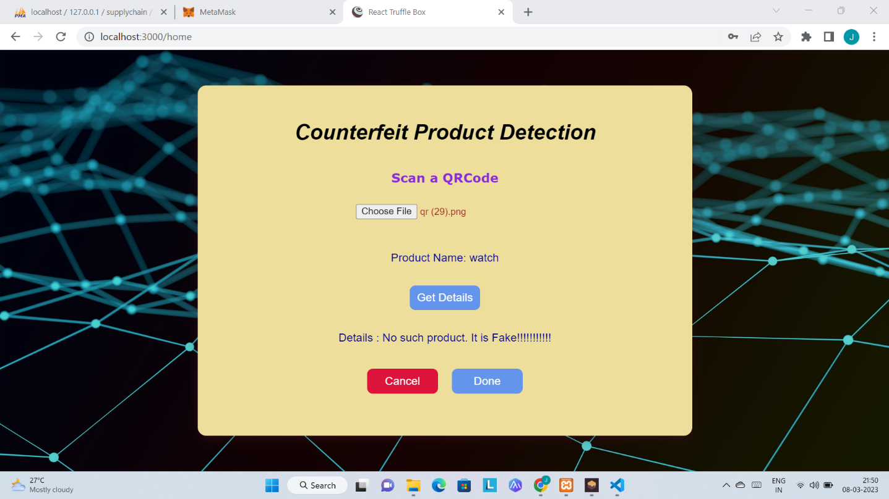

Figure 6.2.10: Detection of Fake Product

**Shipment before Payment**

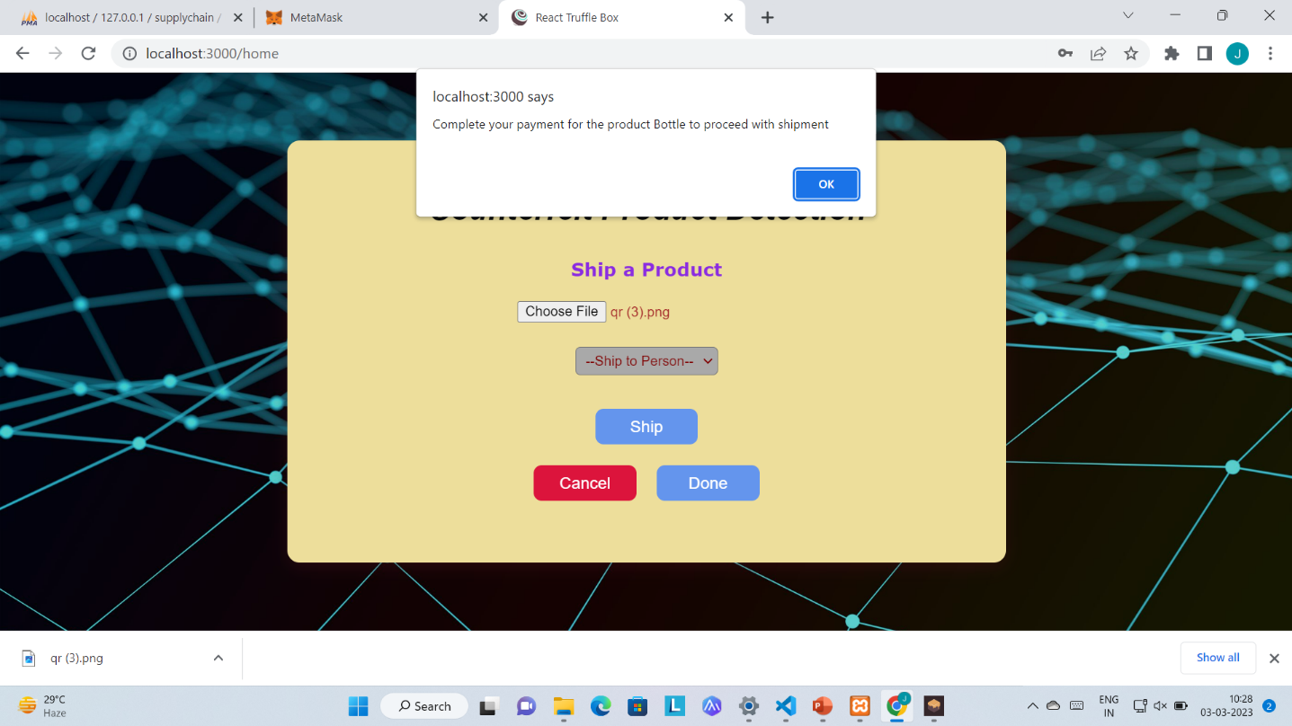

Figure 6.2.11: Shipment unsuccessful Page

**Pay for a Product**

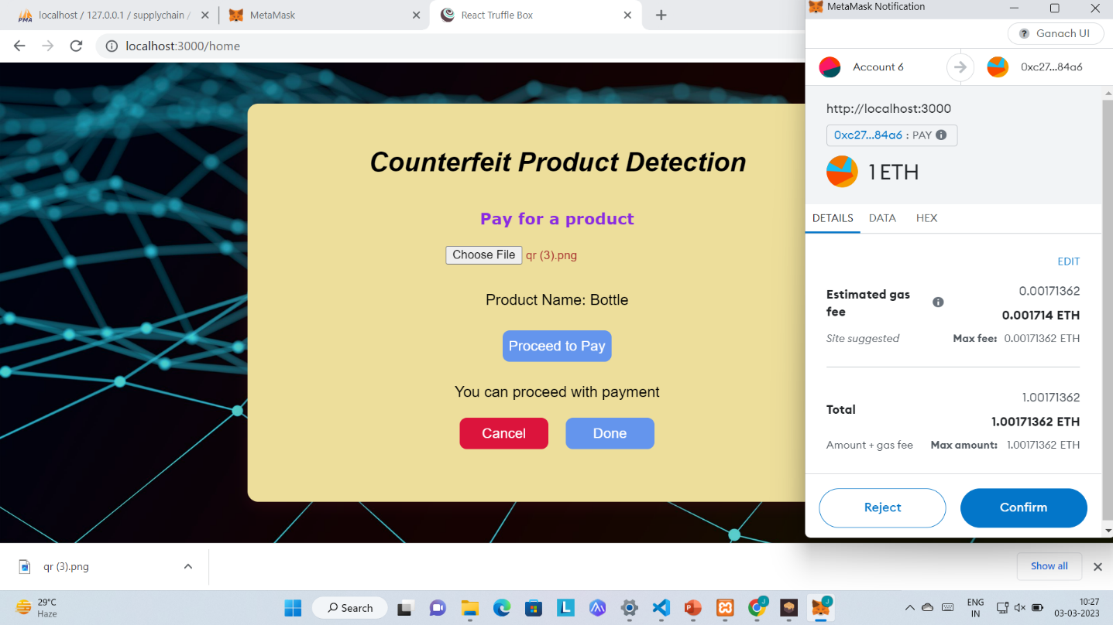

Figure 6.2.12: Payment Page

**Payment Successful**

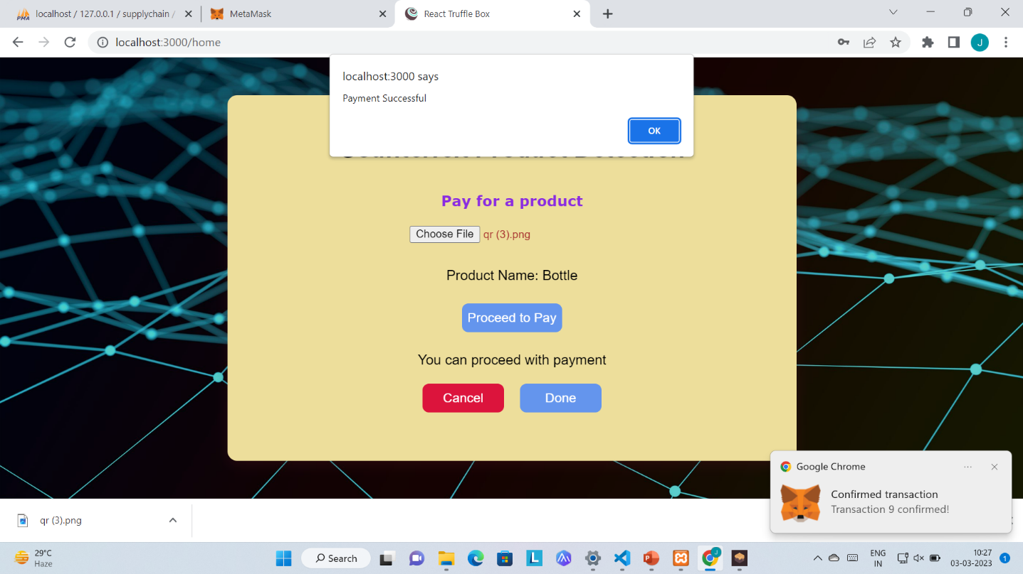

Figure 6.2.13: Payment Successful Page

**Home Page of Customer**

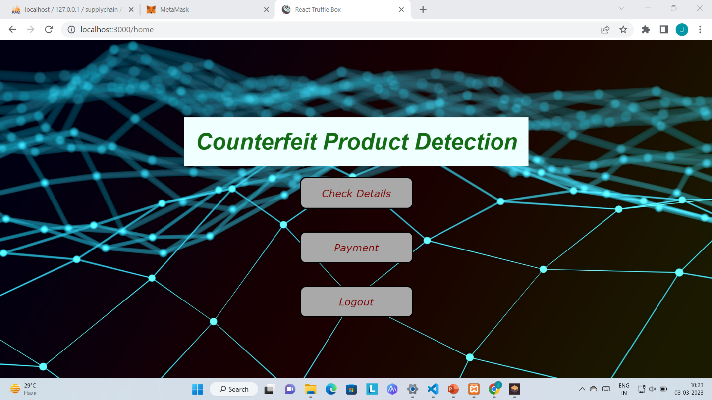

Figure 6.2.14: Home Page of Customer

**Ganache Account Balances**

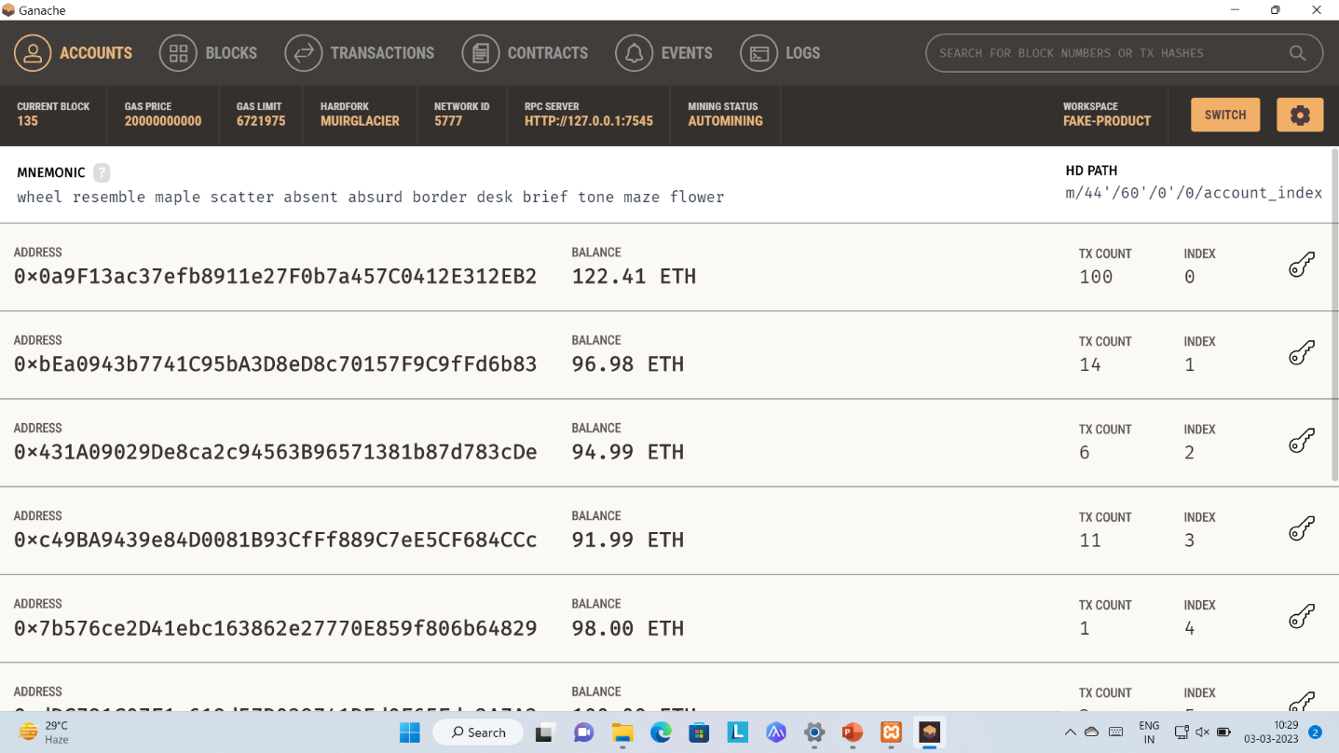

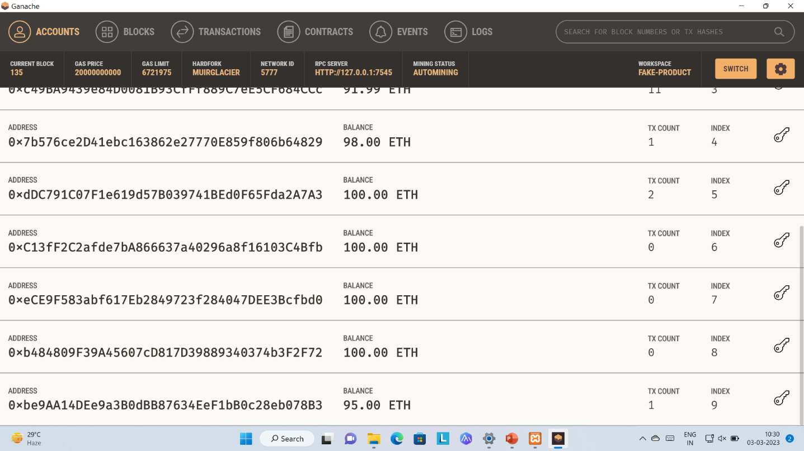

Figure 6.2.15,16: List of Ganache Accounts with Balances